Don’t leave it to chance.....
leave it to LAST CHANCE
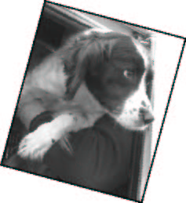  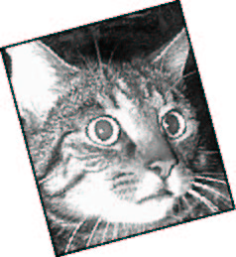  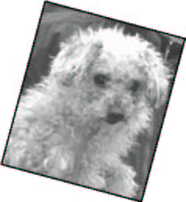 |  | As animals can’t speak for themselves it falls to me to ask you to consider leaving a legacy to Last Chance Animal Rescue.  Any money that we may receive will be spent entirely on the running and improvement of the Centre, which is dedicated to the rescuing, rehabilitating and re-homing of dogs and cats etc.  Many of the number we receive have found their way to our door through circumstances such as their beloved owner passing away, may that door always be open. Many are elderly, in their twilight years, and would just love to find a caring retirement home; something we have great success and pleasure in finding for them, and we continue to care for them, young and old, long after they are settled in their new loving homes, by offering all kinds of support, including financial if needed, for their continued welfare and well being. As you can imagine this level of commitment doesn’t come cheaply, which is why I am appealing to you to remember Last Chance if possible, when you make your Will.  If you would like us to take care of your pets in your absence please remember to include instructions to this effect and if possible inform us of your wishes.  I hope you will consider us a worthy charity; it would be wonderful to think that with your help, Last Chance could always be there to pick up the pieces in times of need.  They do say where there’s a Will there’s a way!
I would like Last Chance Animal Rescue to care for and re-home my pet/s in the
event of my death.

Name …………………………………………………………………………………………..

Address………………………………………………………………………………………..

Type of Pet/s………………………………………………………………………………….

LAST CHANCE ANIMAL RESCUE, HARTFIELD ROAD, EDENBRIDGE, KENT TN8 5NH
Registered Charity No. 1002349

